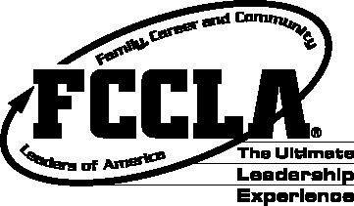
SAMPLE RELEASE TO BE ADAPTED FOR USE ON THE LOCAL LEVEL

Contact: (chapter name)
(address)
(phone number)

Students from (school name) attended the 2025 Missouri Family, Career and Community Leaders of America (FCCLA) State Leadership Conference, March 16-18, 2025, at Margaritaville Lake Resort and Conference Center in Osage Beach. Almost 1,283 delegates from across the state represented more than 9,263 members of Missouri FCCLA.
The following (chapter name) members attended the conference: (name) son/daughter of (parent's/guardian's name) [repeat as many times as needed]. Local chapter adviser/advisers (name/names) also attended.
The conference centered on the student-developed theme “Missouri FCCLA: The Greatest Show” representing how Missouri FCCLA members are showcasing their spectacular leadership skills. The conference kicked off with the Opening General Session on Sunday evening where the 2024-2025 Missouri FCCLA State Executive Council presided. The keynote speaker was John Beede.
On Monday, almost 856 students participated in more than 30 competitive STAR Events – Students Taking Action with Recognition. Events included Entrepreneurship, Culinary Arts, Job Interviews, Chapter Service Projects, Event Management, Early Childhood Education, Sports Nutrition, and many others. (include information on local participants if applicable.) For the first time ever 132 Missouri students were able to participate in Show Me Skills. Events included $20 Clothing Challenge, Cake Decorating, Fiber Art, Impromptu Speaking, Pin It!, PR Photo Challenge, Toward New Horizons, Toys that Teach, and Venture NLC. (include information on local participants if applicable.)

Students also were able to attend workshops on leadership development, community service, career preparation, and healthy living. Exhibits from Missouri colleges, universities, and vendors were also present at the conference. Student voting delegates elected the 2025-2026 Missouri FCCLA State Executive Council and raised money for our state outreach project benefitting MO-NACA.
FCCLA is unique among student organizations because projects and events--such as the State Leadership Conference--are planned and run by its student members. This prime focus of Missouri FCCLA, youth-centered leadership, helps members develop those "skills for life"—planning, goal setting, problem solving, decision-making, and interpersonal communication—necessary in the work place and in the home.

